Plainly Dissimilar is Plainly Dysfunctional
The Federal Circuit’s Latest Use of Feature Filtration and Fact-Finding to Decide Design Patent Infringement
Authors: Christopher V. Carani, Philipp Ruben, Sean Sparrow
In Range of Motion Products, LLC v. Armaid Company Inc., the U.S. Court of Appeals for the Federal Circuit recently upheld the District of Maine’s grant of summary judgment of noninfringement in a design patent dispute involving handheld body-massaging devices. Range of Motion Products (“RoM”) is the owner of U.S. Design Patent No. D802,155, which is embodied in its commercially available “Rolflex” massager. Armaid Company Inc. (“Armaid”) sells the accused product, the “Armaid 2,” and previously marketed a similar device, the “Armaid 1”, which Armaid asserts is covered by its U.S. Utility Patent No. 5,792,081. Below is a comparison of the D’155 design patent, and the Armaid 2 accused design.
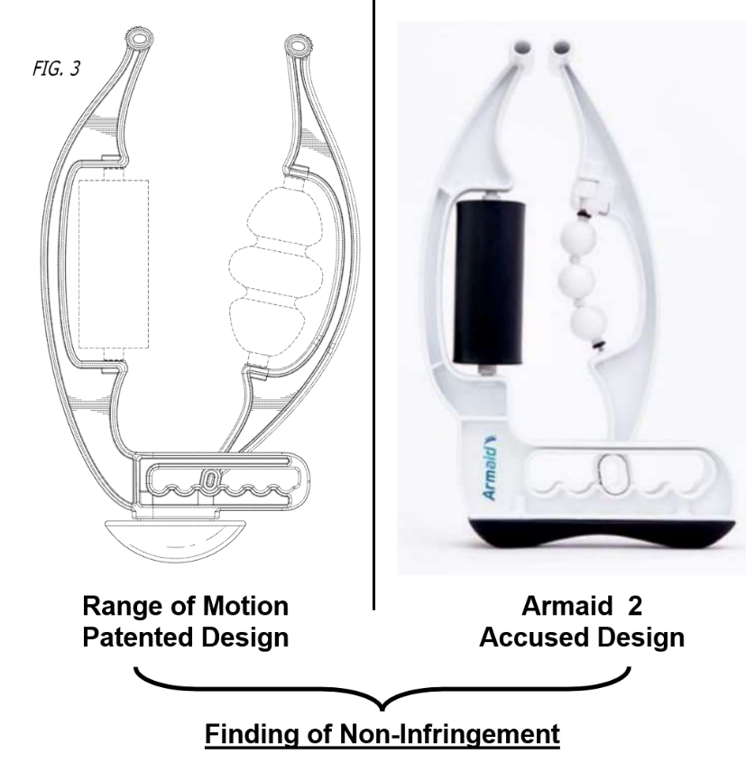
RoM initially sued Armaid in 2021 for infringement of the D’155 design patent in the District of Maine, but stipulated to dismissal following the district court’s denial of RoM’s motion for a preliminary injunction. RoM refiled its claims for design patent infringement a year later in 2022. The district court granted summary judgment of noninfringement in favor of Armaid, concluding that, viewing the evidence and drawing all reasonable inferences in RoM’s favor, there was no genuine dispute of material fact and no reasonable jury could find infringement.
Writing for the majority, Judge Cunningham, joined by Judge Hughes, affirmed the district court’s decision on two grounds: (1) a claim construction that filtered out certain visual features of the claimed design on the basis that the features were “functional,” and (2) a finding of noninfringement based on the conclusion that the filtered subsect of the claimed design and the corresponding portion of the accused design were “plainly dissimilar” in their “overall” appearance.
Claim Construction and Factoring-Out of Functional Features
With respect to claim construction, the Federal Circuit agreed with the district court’s approach of construing the claim by conducting a functional-versus-ornamental inquiry to “factor out the functional aspects of the design.” In particular, the Court determined that several visual features of the D’155 patent—such as the shape of each of the device’s arms—were driven by function. The majority appeared to place significant weight on disclosures in the related ’081 utility patent. In particular, the Court pointed to language in the ’081 utility patent that described the functional purpose of the arms, as contributing to its conclusion that the shape of those arms was functional.
The authors observe that factoring out the arms’ shape from the claimed overall appearance is at odds with prior Federal Circuit precedent, which cautions against eliminating visual features from a claimed design. See Sport Dimension, Inc. v. Coleman Co., 820 F.3d 1316, 1321 (Fed. Cir. 2016) (holding that while a court may identify functional aspects of a design, it is legal error to eliminate claimed visual elements from the design during claim construction); see also Ethicon Endo-Surgery, Inc. v. Covidien, Inc., 796 F.3d 1312, 1335–36 (Fed. Cir. 2015) (rejecting claim constructions that effectively excise claimed visual features under the guise of functionality).
Effectively removing visual features from a claimed design, instead of focusing on the overall design, is fraught with doctrinal problems. It risks distorting the scope of the claim, which undermines the presumption of validity by redefining the claim into something other than what the USPTO examined. Moreover, the removal of visual features on the basis of functionality inadvertently broadens the claim by isolating a residual sub-portion that was never claimed on its own. The practice also appears to undermine the ordinary observer test by preventing comparison of the full claimed appearance. See Christopher V. Carani, Design Patent Functionality: A Sensible Solution, ABA Landslide® (Nov./Dec. 2014).
While fact-finders should be reminded that similarity in functional attributes, such as strength, torque, or range of motion, are irrelevant to design patent infringement, the fact that a design has such functional purposes does not justify excising visual features from the claimed overall design. Claim construction should not be used to dissect and divide out visual elements of the overall claimed design. By analogy, in the novelty context, the relevant inquiry is whether the overall claimed design is novel; individual features are not factored out of the claim merely because those features may appear in the prior art. The same holistic principle should govern the assessment of ornamentality and infringement in design patent law. Functionality, or more precisely lack of ornamentality, is solely a question of validity to be assessed at the macro level i.e., whether the appearance of the design as a whole is dictated solely by function, not at the micro, feature-by-feature level. See Christopher V. Carani, All or Nothing at All: Design Patent’s Ornamentality Requirement and the Failings of Feature Filtration, 36 Berkeley Tech. L.J. 213 (2021).
If a petition for rehearing or rehearing en banc is sought, this tension between Range of Motion and prior Federal Circuit precedent on feature filtration and claim construction is likely to be brought squarely back to the court’s attention.
Plainly Dissimilar and Thus Not Infringed
The Court explained that it did not wholly eliminate visual features, such as the arms, as it still considered them “for their ornamental aspects and the way they contribute to the overall design.” But the opinion makes clear that court did “factor out” at least the shape of the arms on the basis of functionality. Indeed, the Court cites with approval the controversial practice of using “claim construction to remove functional elements from design patents.” It was only after the Court “separate[d] out functional aspects,” that it concluded that the few remaining aspects of the claimed design, when compared to the corresponding portions of the accused Armaid 2, were “plainly dissimilar” in appearance. Accordingly, the Court appears to have expressly excluded from the infringement analysis any visual similarities between the claimed design and the accused product in the factored-out areas, such as the shape of the arms.
The Dissent
Chief Judge Moore dissented, sharply criticizing the majority’s reliance on the “plainly dissimilar” framework at the summary judgment stage. In her view, the ordinary observer test articulated by the Supreme Court in Gorham Co. v. White, 81 U.S. 511 (1871) requires a fact-intensive assessment of whether the overall designs are substantially the same, a question that should ordinarily be reserved for the jury. Further, she astutely pointed out that focusing on differences, rather than similarities, distorts the infringement analysis and strays from the test articulated by the Supreme Court in Gorham v. White. An analytical focus on differences frames the inquiry in a manner that biases the analysis toward a finding of noninfringement and in turn risks stripping juries of their role in design patent cases. Looking at the images of the asserted D’155 patent and Armaid 2 side by side, especially in view of the prior art, the dissent maintained that a reasonable juror could find the designs substantially the same. Forecasting the slippery slope of the “plainly dissimilar” framework set forth in Egyptian Goddess, Inc. v. Swisa, Inc., 543 F.3d 665 (Fed. Cir. 2008), Chief Judge Moore proclaimed: “I think we ought to correct our error in Egyptian Goddess and reaffirm that the substantially similar test, announced by the Supreme Court in Gorham, is ‘the sole test.’”
The dissent honed in on the notion that the “plainly dissimilar” framework appears to have been taken out of context from its mention in Egyptian Goddess. In particular, Judge Moore explains that “Egyptian Goddess merely recognizes that in some cases, the claimed and accused designs may be so clearly not similar (or ‘dissimilar’) as to remove the need to consider the prior art.” To correct this misinterpretation, the dissent, in following Gorham, suggests that the infringement analysis should “always ‘compare the claimed and accused designs in light of the prior art, with no special exception for plainly dissimilar designs,” as the latter has “proved unworkable.”
In Gorham, the Supreme Court found that White's spoon design infringed Gorham's patented spoon design as of result of the similarities in overall appearance between the two, rather than their perceived lack of differences. An inquiry, which is properly framed by a comparison of the prior art, should be left to the jury. It is worth noting that, unlike the majority’s feature-filtration approach, the Supreme Court in Gorham made no effort to remove visual features from the claimed design (such as the functional handle and mid-section stem) on the basis of functionality. Instead, the Court compared the overall claimed design to the corresponding overall appearance of the accused utensil.
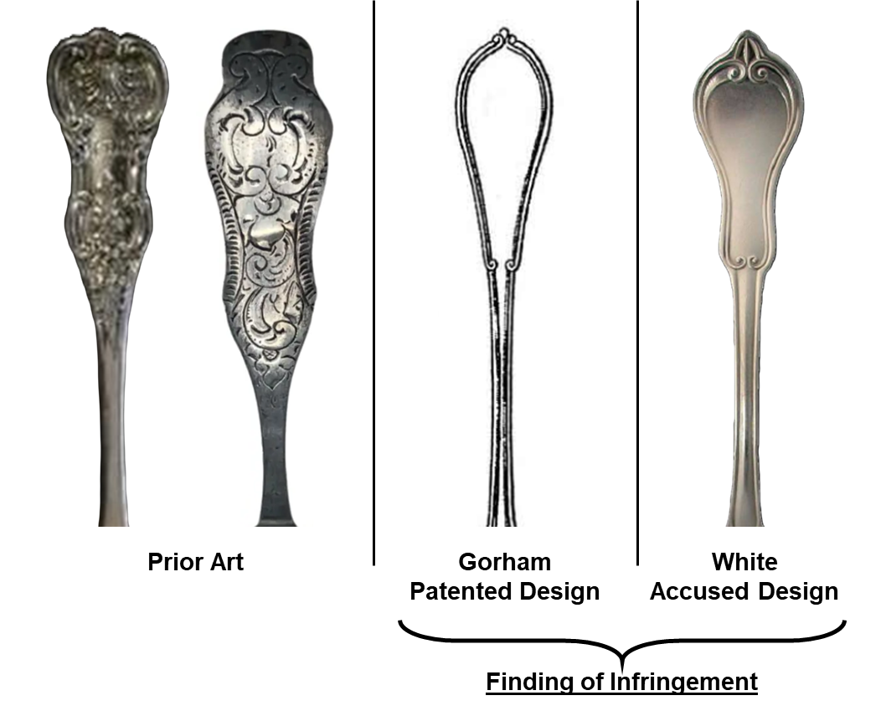
The Range of Motion decision thus highlights an ongoing tension in Federal Circuit design patent jurisprudence between early judicial resolution and the traditional role of juries in resolving genuine disputes of material fact concerning infringement. The divide reflected in Range of Motion v. Armaid, together with recent decisions such as North Star Technology International Ltd. v. Latham Pool Products, Inc., No. 23-2138, 2025 WL 1189919, at *1–2 (Fed. Cir. Apr. 24, 2025), suggests that further clarification, potentially through en banc review or Supreme Court intervention, is desperately needed.

